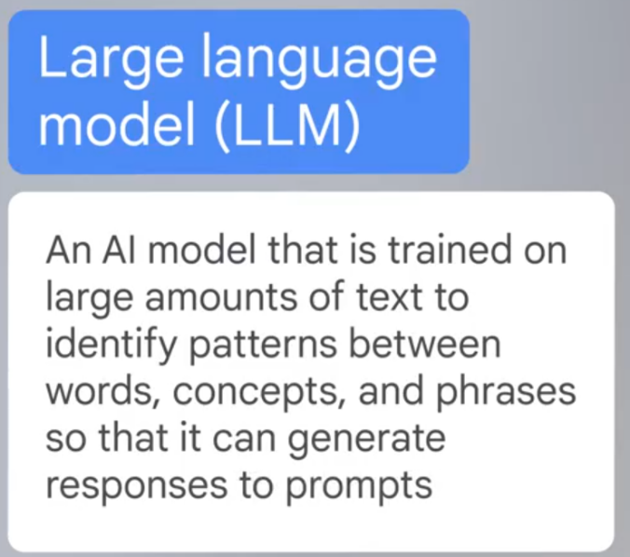**MODULE : 3**

An LLM is trained on millions of sources of text,

including books, articles, websites, and more.

This training helps the model learn the patterns

and relationships that exist in human language.

In general, the more high quality data the model receives,

the better its performance will be.

Because LLMs can identify so many patterns in language,

they can also predict what word is most likely to come next

in a sequence of words.

Consider a simple example to get a basic understanding

of how LLMs predict the next word in a sequence.

****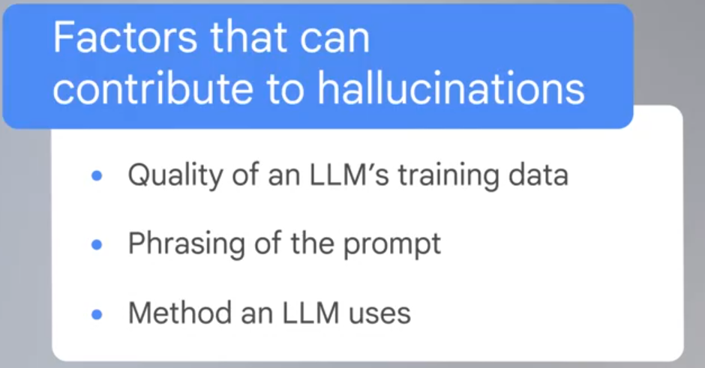

**Prompts for different purposes**

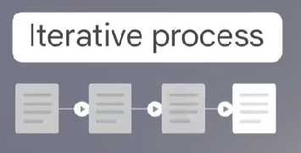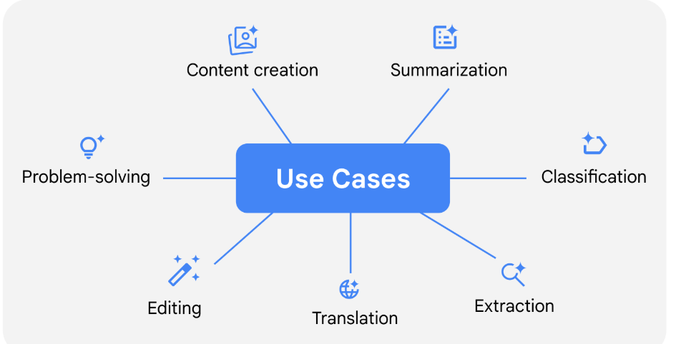  
  
  
  
  
  
  
  
  
  
  
  
  
  
  
  
In an iterative process,

you create a first version, evaluate it,

and improve upon it for the next version.

Then you repeat these steps

until you get the desired outcome.

For example, if you're developing a proposal, report

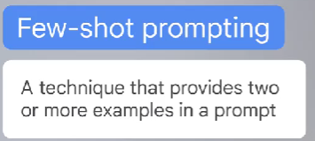or other document to share with your coworkers,

you might produce multiple drafts

and make improvements on each draft,

until you are satisfied with the result.



  
  
  
